**SERIES R, L, C**

**CIRCUITS**

**LAB # 04**



**Fall 2022**

**CSE-203L**

**Circuits & System-2 Lab**

Submitted by: **NAVEED AHMAD**

Registration No.: **22PWCSE2165**

Class Section: **B**

“On my honor, as student of University of Engineering and Technology, I have neither given nor received unauthorized assistance on this academic work.”

Student Signature: ______________

Submitted to:

**Engr. Usman Malik**

Nov.2023

Department of Computer Systems Engineering

University of Engineering and Technology, Peshawar

Series R, L, C Circuits

**Objective of the lab:**

The objective of this experiment is to study the behavior of an RLC series circuit subject to an AC input voltage. The student will measure the circuit current, the voltages across the resistor and the generator

This exercise examines the voltage and current relationships in series R, L, C networks. Of particular importance is the phase of the various components and how Kirchhoff’s Voltage Law is extended for AC circuits. Both time domain and phasor plots of the voltages are generated.

**THEORY:**

Each element has a unique phase response: for resistors, the voltage is always in phase with the current, for capacitors the voltage always lags the current by 90 degrees, and for inductors the voltage always leads the current by 90 degrees. Consequently, a series combination of R, L, and C components will yield a complex impedance with a phase angle between +90 and -90 degrees. Due to the phase response, Kirchhoff’s Voltage Law must be computed using vector (phasor) sums rather than simply relying on the magnitudes. Indeed, all computations of this nature, such as a voltage divider, must be computed using vectors.

**COMPONENTS:**

* 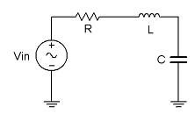AC Function Generator
* Oscilloscope
* 10 nF actual:
* 10 mH actual:
* 1 kΩ actual:

Circuit Diagram

**CIRCUIT AND FIGURES:**

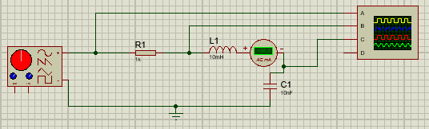

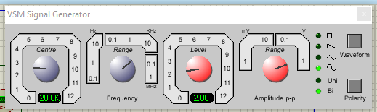

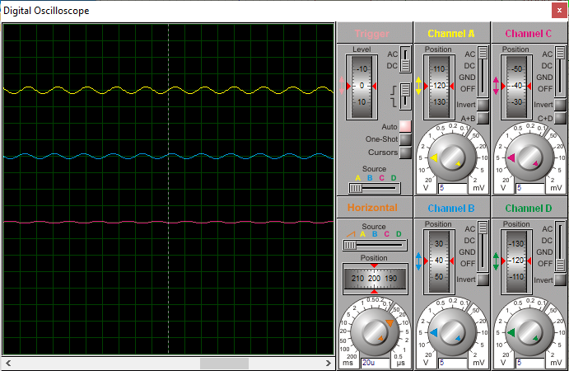

Procedure:

* Using Circuit with Vin=2Vp-p sine at 10 kHz, R=1kΩ, L=10mH and C=10nF, determine the theoretical inductive and capacitive reactance and circuit impedance, and record the results in Table 1 (the experimental portion of this table will be filled out in step 4). Using the voltage divider rule, compute the resistor, inductor and capacitor voltages and record them in Table 2.
* Build the circuit of using R=1kΩ, L=10mH and C=10nF. Set the generator to a 10 kHz sine wave and 2 Vp-p. Using oscilloscope measure the signals. Unfortunately, it is impossible to see the voltages of all the three components simultaneously using only two probes of the oscilloscope. To obtain the proper readings, place one probe on the function generator to see the input signal and the second probe across the last element. This step is repeated three times. The first time the components are so arranged that capacitor is the last component, the second time inductor is connected as the last component and finally resistor is made the last component. The peak-to-peak voltages and phase angles of each one of the three components, relative to the source are thus determined in turn. Thus Vs, VC, VL and VR are measured. Record in Table 2.
* Compute the deviations between the theoretical and experimental values of Table 2 and record the results in the final columns of this table.
* Based on the experimental values, determine the experimental Z, XL and XC values via Ohm’s Law (i=VR/R, XL=VL/i, XC=VC/i, Z=Vin/i) and record back in Table 1 along with the deviations.
* Create a phasor plot showing Vin, VL, VC, and VR.
* Repeat the experiment for 1nF capacitor, 1mH inductor and 1kΩ resistor.

**Observation and Calculation:**

**Table 1**

|  |  |  |  |
| --- | --- | --- | --- |
|  | **Theoretical** | **Experimental** | **%Deviation** |
| **XC** | 568.698 ohm | 466.66 ohm | 21.865 |
| **XL** | 1758.4 ohm | 1806.667 ohm | 2.617 |
| **Z** | 1554.152 ohm | 1672.010 ohm | 7.048 |
| **Ɵ** | 49.95 | 53.267 | 6.626 |

**Table 2**

|  |  |  |  |
| --- | --- | --- | --- |
|  | **Theoretical** | **Experimental** | **%Deviation** |
| **VC** | 255.914 mV | 0.210 V | 21.428 |
| **VL** | 791.28 mV | 0.813 V | 2.706 |
| **VR** | 450 mV | 0.430 V | 4.651 |
| **VS** | 2V | 2V | 0.00 |
| **Ɵ** | 49.951 | 54.07 | 7.613 |

**Conclusion:**

The series RLC circuit is simply an association in series of the three elementary components of electronics: **resistor, inductor,** and **capacitor.** The impedance of a resistor is a real number and the impedances of the inductor and capacitor are pure imaginary numbers, the total impedance of the circuit is a sum of these three impedances and is, therefore, a complex number.

RLC circuits have countless applications outside of being filters. For example, RLC circuits are used for voltage magnification and parallel RLC circuits can be used for current magnification. Another use for RLC circuits is in induction heating.

In this lab, we were able to analyze RLC circuits as Alternating current was applied to the

circuit instead of DC. We used different methods to calculate or measure the frequency,

especially at resonance. That sad, we also got to find the resonance frequency with the use of

Lissahous figure and also with the use of pre-known formulas. Most importantly though, we got

a parabolic curve for the graph. The resonance was near what we calculated in regards to the

theoretical value. A source of error is not accurately recording that voltages as frequency is

changed. Another source of error is the not counting the divisions on the oscilloscope closely

enough.

In this lab, we were able to analyze RLC circuits as Alternating current was applied to the

circuit instead of DC. We used different methods to calculate or measure the frequency,

especially at resonance. That sad, we also got to find the resonance frequency with the use of

Lissahous figure and also with the use of pre-known formulas. Most importantly though, we got

a parabolic curve for the graph. The resonance was near what we calculated in regards to the

theoretical value. A source of error is not accurately recording that voltages as frequency is

changed. Another source of error is the not counting the divisions on the oscilloscope closely

enough.

In this lab, we were able to analyze RLC circuits as Alternating current was applied to the

circuit instead of DC. We used different methods to calculate or measure the frequency,

especially at resonance. That sad, we also got to find the resonance frequency with the use of

Lissahous figure and also with the use of pre-known formulas. Most importantly though, we got

a parabolic curve for the graph. The resonance was near what we calculated in regards to the

theoretical value. A source of error is not accurately recording that voltages as frequency is

changed. Another source of error is the not counting the divisions on the oscilloscope closely

enough.

In this lab, we were able to analyze RLC circuits as Alternating current was applied to the

circuit instead of DC. We used different methods to calculate or measure the frequency,

especially at resonance. That sad, we also got to find the resonance frequency with the use of

Lissahous figure and also with the use of pre-known formulas. Most importantly though, we got

a parabolic curve for the graph. The resonance was near what we calculated in regards to the

theoretical value. A source of error is not accurately recording that voltages as frequency is

changed. Another source of error is the not counting the divisions on the oscilloscope closely

enough.

In this lab, we were able to analyze RLC circuits as Alternating current was applied to the

circuit instead of DC. We used different methods to calculate or measure the frequency,

especially at resonance. That sad, we also got to find the resonance frequency with the use of

Lissahous figure and also with the use of pre-known formulas. Most importantly though, we got

a parabolic curve for the graph. The resonance was near what we calculated in regards to the

theoretical value. A source of error is not accurately recording that voltages as frequency is

changed. Another source of error is the not counting the divisions on the oscilloscope closely

enough.

In this lab, we were able to analyze RLC circuits as Alternating current was applied to the

circuit instead of DC. We used different methods to calculate or measure the frequency,

especially at resonance. That sad, we also got to find the resonance frequency with the use of

Lissahous figure and also with the use of pre-known formulas. Most importantly though, we got

a parabolic curve for the graph. The resonance was near what we calculated in regards to the

theoretical value. A source of error is not accurately recording that voltages as frequency is

changed. Another source of error is the not counting the divisions on the oscilloscope closely

enough.